**Problem**

**Find out the districts who achieved 100 percent objective in BPL cards**

**Export the results to mysql using sqoop**

**Pig Script to calculate 100% Objective**

**input data set**

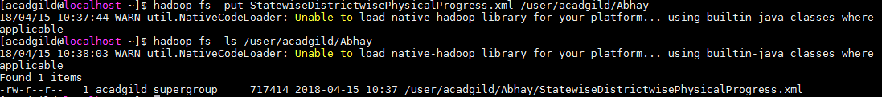

**Problem1.pig**

**Attached scripts**



**Output**

**1.executed above script** as pig -x local pig_scripts.pig

Output screen as below

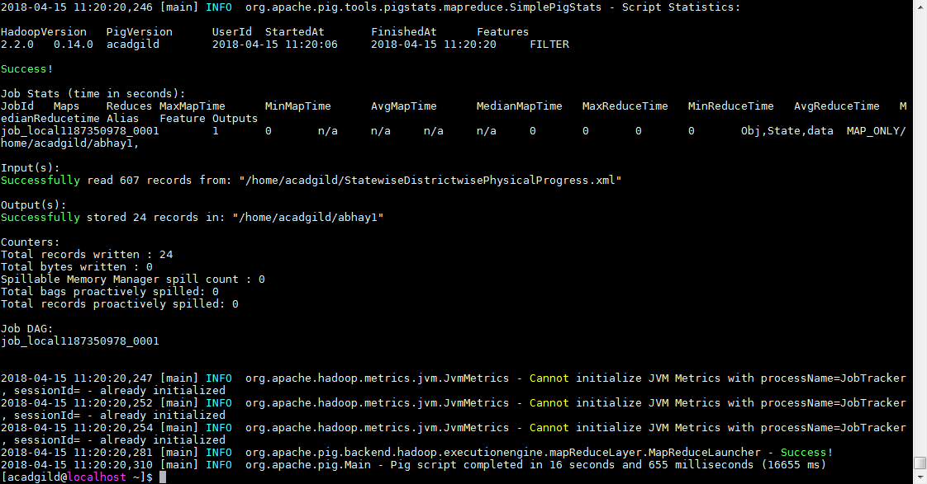

File create



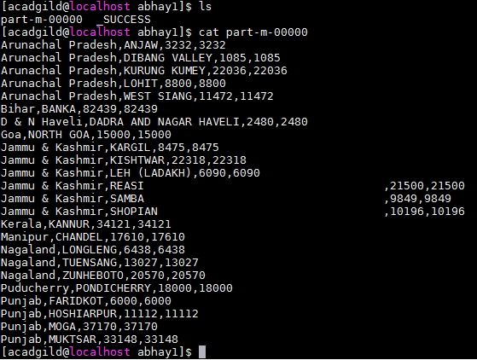

**Copy the output to HDFS**

Run MySQL using the following commands

sudo service mysqld start

as

mysql -u root

Create a new Database:

mysql>create database state;

mysql>use state;

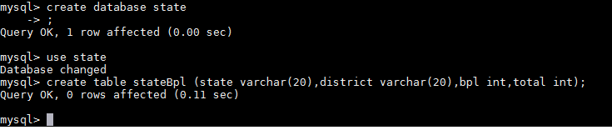

**Run the sqoop command to Export the Pig Script analysis from HDFS to MySQL**:

sqoop export --connect jdbc:mysql://127.0.0.1/state -username root --table stateBpl --export-dir /analysis/part-m-00000 --input-fields-terminated-by ',' -m 1

output screen

